Quality Assurance Engineering Intern
Here is a bit of information on our company for you to look through:
- ⁠Company Details: simpleloyalty.com (previously mulahrewards.com)
- ⁠Job Role: https://bit.ly/MHiredlyQA

This is also what you can expect when you work with us:
✅ RM1,000 - RM1,200 monthly stipend depending on your performance
✅ Interesting and rewarding work: see the impact of your work quickly in the world
✅ Work for a rapidly growing startup: we are in 4 cities in 2 countries, hoping to work with larger retail and F&B companies: Harvey Norman, etc
✅ Latitude and leeway to learn: you will be afforded the opportunity to learn on the job and do what you do best!
✅ You'll be given a wide latitude to do your work with a high amount of autonomy
✅ Stand on the shoulders of your seniors
✅ Great working environment with a team of young, energetic people

Our office is in Subang USJ and we work from the office 5 days a week. Here are your next steps:
- ⁠Please complete the assignment on the next page - it will take you about ±45 minutes
- Fill in This Form. Under the “Role you have applied for”, select “Internship - Quality Assurance Associate MY”
- ⁠if you qualify, we will invite you for an interview:
  - technical assessment which would take ~1.5 hours
  - verbal interview

Thank you.

Assessment 1
Testing the SMS Credit Reload Feature for a Digital Loyalty Software

MikeTango sells a product called GoSMS to their clients which can:
- Send Birthday SMSes to their customers (for example: MikeTango’s client, SilverTree Restaurant, sends their customers birthday greetings every year)
- Send SMS Campaigns during festive seasons: during Christmas, New Year or Hari Raya
These clients will need to buy prepaid SMS credits from MikeTango for their services. The SMS credits are used to send the types of SMSes above.
MikeTango wants to integrate their software with an accounting software called Quickbooks for these SMS payments to save on administrative workload. This feature allows MikeTango to generate quotations and credit their client’s accounts automatically.
Under each client, there could be a single brand with multiple outlets under different companies. SMS credits are charged and credited to separate companies instead as a whole across the entire brand. Here is a prototype of the product which MikeTango has built:
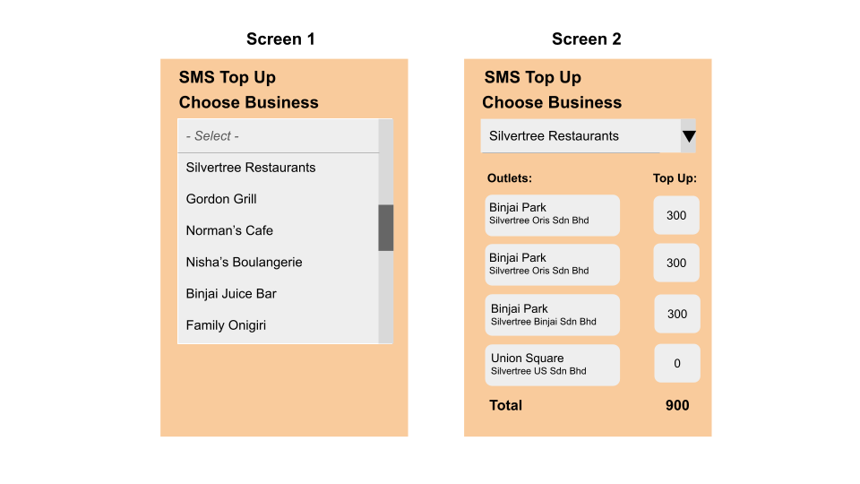
Here is how the feature works:
- MikeTango’s finance executive will select a brand (as in screen 1)
- Once the brand is selected, all the outlets under the brand appears (as in screen 2)
- The finance executive can populate the “top up” field
- Click next and a quotation will be generated and sent to the client’s email as provided in MikeTango’s database
- Once the quotation is successfully generated, the SMSes will be credited into the client’s account with MikeTango

Assessment 2
For this feature:
- Create a flowchart for the entire feature which includes methods to mitigate errors. Please also include the error messages etc)
- List out the test cases that you will use to evaluate this feature. All complete state transitions should be covered by the test cases, and repeat testing of the same state transition should be avoided. Click here for a guide to state transitions) which should be covered by the test cases.

You may refer to this Youtube Video to learn more about Test Cases.

